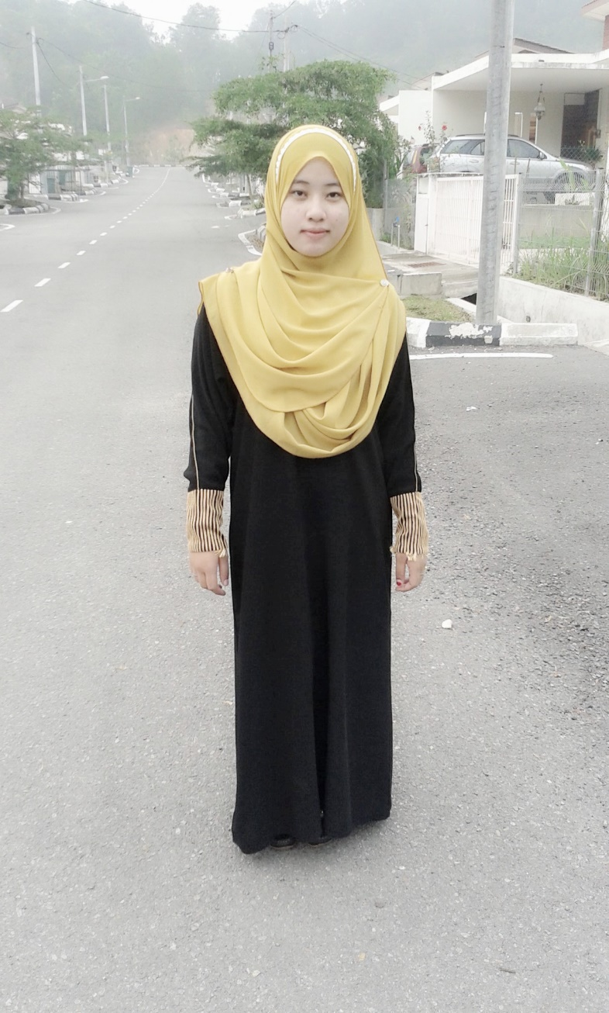

Nur Athirah Binti Azman

Phone: 017-2032159 | Email: [athirahazman40@gmail.com](mailto:athirahazman40@gmail.com)

Address: T 256 Taman Inderapura Fasa 3, 27000 Jerantut Pahang

|  |  |  |
| --- | --- | --- |
|  | EDUCATION |  |
|  |  |
| DIPLOMA IN MOBILE TECHNOLOGY  Ampang Community College  2018 | CERTIFICATE IN COMPUTER SOFTWARE APPLICATION  Temerloh Community College  2016  CGPA : 3.80 | SIJIL PELAJARAN MALAYSIA  SMK Desa Tun Hussien Onn Kuala Lumpur  2013 |

|  |  |  |
| --- | --- | --- |
|  | WORK EXPERIENCE |  |
|  |  |
| JOBTITLE, COMPANY, DATE FROM-TO   * Junior Computer Software And Application Technician at Department of Survey and Mapping Malaysia (Information System Management) - November 2015 to February 2016 * Sales Associate at Vern’s Shoes Store - April 2016 to October 2016 * Housekeeping at ATM Transit Home - December 2013 to March 2014  |  |  |  | | --- | --- | --- | |  | PERSONAL STRENGTH |  | |  |  | | * Have a good sense of a teamwork and able to handle work independently. * Love challenges and willing to upgrade skills and knowledge. * Confident, flexible and able to solve problems creatively. * Willing to accept criticism and easily adapt in new environment. | | | | | |

|  |  |  |
| --- | --- | --- |
|  | KEY SKILLS |  |
|  |  |

|  |  |
| --- | --- |
| COMPETENT IN :   * Graphic Design * Apps Development * Mobile Device Repairing * Network and Trouble Shooting | COMPUTER SKILLS :   * Microsoft Office (Words, Power point, Excel) * Microsoft Access * Adobe Photoshop * Adobe Illustrator * Netbeans * Macromedia Dreamweaver * Java * Objective C++ |
| LANGUAGE SKILLS :   * Bahasa Inggeris 7/10 * Bahasa Melayu 10/10 | ACHIEVEMENT  (Description/Date/Details)  Academic   * Director’s Award March 2017 Dean’s List * Merdeka day welfie August 2017 Gold   competition   * Merdeka day challenge August 2017 Silver * Ampang CC Stompers August 2017 Participant   Competency Course   * Blog Development July 2017 Cert. * Google Sketchup September 2015 Cert. * I-success Motivation September 2015 Cert.   Volunterism   * IM4U Game Sport April 2017 Participant * IM4U Mountain Bike September 2014 Participant * Ampang Fest December 2016 Participant |

|  |  |  |
| --- | --- | --- |
|  | REFERENCE |  |
|  |  |
| **En. Mohd Faisal Bin Ishak**  Principal Lecturer  Ampang Community College  Tel : 03 42800201  H/p : 012-6260202  Email : [mfi.kkas@gmail.com](mailto:mfi.kkas@gmail.com) | | |